***Project Phase III Report***

***On­­­***

Parking Space Counter

**Submitted for the requirement of**

**Project course**

BACHELOR OF ENGINEERING

**COMPUTER SCIENCE & ENGINEERING**



**Submitted to:**

**Ms Neha (E12269)**

**Submitted By:**

|  |  |
| --- | --- |
| **Name** | **UID** |
| Mehakpreet Kaur | **20BCS1320** |
| Abhijeet Kaur | **20BCS1326** |
| Rishit Gupta | **20BCS1270** |

**Co Supervisor Signature**

**Saroj Kumar (E11946)**

**DEPARTMENT OF COMPUTER SCIENCE & ENGINEERING**

**CHANDIGARH UNIVERSITY, GHARUAN**

**June 2022**

**ABSTRACT**

The main aim of this project is to reduce the traffic in the parking place. Normally we can see in the multiplexes, cinema halls, large industries, and function halls there is problem they have to go and search which line is empty and which line having place to park the vehicle, for parking then they need workers for parking in correct position it is the money consumed process. So to avoid this problem Car Parking System project is implemented.

The parking space counter undertaken as a project is based on relevant technologies. This project has been developed to carry out the processes easily and quickly, which is not possible with the manuals systems, which are overcome by this software. This project is developed using OpenCv with Python.

The project analyzes the system requirements and then comes up with the requirements specifications. It studies other related systems and then come up with system specifications. The system is then designed in accordance with specifications to satisfy the requirements.

Parking Space Counter find how many total cars are present and how many spaces are vacant to park. In this project, we will be using basic Image Processing techniques to solve this problem

**TABLE OF CONTENT**

|  |  |  |
| --- | --- | --- |
| Sr no. | Topic | Page No. |
| 1 | Feature/characteristics identification | 4 |
| 2 | Constraints Identification | 8 |
| 3 | Analysis of features and finalization subject to constraints | 9 |
| 4 | Design selection | 10 |

|  |  |  |  |
| --- | --- | --- | --- |
|  | |  |  |
|  | | |  |
|  | | |  |
|  | |  |  |
|  | |  |  |
|  |  | |  |

1. **Feature/characteristics identification**

* **Automated Access control system**

**It automatically detect empty space on the spot or detect the empty space after any car leave the space.**

* **Parking Management Software**

The software regulates & monitors the parking facility requirements, designed to manage the car parking slots & provide useful reports/information to the management.

* **Security Analysis**

The security analyses of the situation are vital before recommending a solution, for example how sensitive is the parking facility and these questions will determine the devices and software solutions that can be integrated in creating a strong and secured parking solution.

1. **Objectives :-**

Objectives of our project will be:-

1. Monitoring car parking area

2. Provide information about the count of free parking spaces.

3. Reduce traffic in the parking area.

1. **Single entity :-**

This Project is mainly Contributed by Rishit Gupta , Mehakpreet Kaur and Abhijeet Kaur with the help of Mr. Saroj Kumar and Ms. Neha. With Our all Effort and Dedication , This Project Meet the Objectives of this Project.

1. **Life Span :-**

|  |  |  |
| --- | --- | --- |
| **S.No** | **Task or Stage** | **Time required (in days)** |
|  | Planning | 2 |
| 2. | Requirement Specification | 2 |
| 3. | Parking Space Picker Module | 5 |
| 4. | Main Module | 10 |
| 5. | Main Module With Trackbars | 5 |
| 6. | Testing | 2 |
| 7. | Deployment | 1 |

1. **Require Funds :-**

This project does not require any external funds as this is a college project and made exclusively by students with the knowledge of Python and OpenCV Libraries and it also doesn’t require any hardware so we do not need any fundings.

1. **Life Cycle :-**

Before creating,we carefully decided the project’s planning and how we will do it. We decided to do it on Software Development Life Cycle (SDLC). Many researchers described the SDLC according to software development models.

* **Planning –** A core theme with well defined target, characters, events is decided. Since we are developing Modules, so we needed to consider Empty Space and its Area and how we are Calculate Space.
* **Feasibility Study –** In this we checked the requirements, the scope, and the other conclusions of our Project. The areas that we analyzed are technical feasibility and operational feasibility.
* **Technical Feasibility –**

We Require Main Module to operate and picker module to work in effective.

* **Operational Feasibility –**
* The database(CCTV or Clip) must contain all the details.
* Database must be update regularly.
* **Building or developing the project** **–** In this stage we write code for background designing, sets and props designing and layout designing and modelling and connecting the project to clip.
* **Testing** –In this stage after developing the complete project we test all the modules and features they are working properly or not. And if there are any bugs or error then we remove it and retest.
* **Deployment –** After the project is completed and tested and all modules are working perfectly, we deploy the project to the client or in the market. But as this is a college project so we will submit it to our project teacher.
* **Team Spirit –** In my team we are three people and divided the tasks on our expertise. we will be basically developing code using libraries and improving the user interface.
* **Risk and Uncertainty –** We do have some risk as connecting the code developed on python will be difficult to connect and mainly risks are involved in backend work to keep users’ data bases intact without compromising with it.
* **Directions -** Project is always performed according to the directions given by the customers with regard to time, quality and quantity, etc. The convenience of the supply sides of economics such as labor availability ore resources and managerial talent etc. are all secondary concerns, primary being the customer requirement. Since, it’s a college project so our guide is our project teacher and our co-supervisor. We take directions from them that which task should be done first and all the development is decided by my team.
* **Uniqueness -** Each project is unique in itself, and it’s having own features. No two projects are similar even if the type of organization is the same. The uniqueness of this project can measure by considering the many factors like objectives, features of the project, application of the project, etc.
* **Flexibility -** Change and project are synonymous. A project sees many changes throughout its life span. These changes can make projects more dynamic and flexible.   
  Our project need flexibility and to give that we are using different libraries like OpenCV, Numpy.
* **Sub-Contracting -** Sub-contracting is a subset of every project and without which no project can be completed unless it is a proprietary firm or tiny in nature. The more complexity of a project the more will be the extent of contracting. Every project needs the help of an outsider consultant, engineer, or expert in that field. It’s a college project and not much big so its complexity level is not high but at moderate level as we have to connect different libraries together and make them work as one.
* **Cost -** If the quality of the project is to be changed there could be an impact on the cost of the project. The cost could increase if more resources are required to complete the project quicker. But we don’t require any cost as it’s a project made by students for college submission and not for some client or to deploy in market.

1. **Constraints Identification:-**

There are six major constraints in project management to consider.

* **Time:** This Project takes Approx one month to Complete with All Modules. It takes that much time because of learning phase and to understand libraries.
* **Cost:**  This Project doesnot cost money as it is software Project on open platform. It cost only Our time and Our Effort.
* **Scope:** It Except theMonitor car parking area, Provide information about the count of free parking spaces, Reduce traffic in the parking area.
* **Quality:** Quality of the Project Meets the Objectives of this Project. It fulfill all Requirement of the Project.
* **Benefits:** ItReduces unnecessary vehicle emissions caused by parking search traffic and Saves time and hassle for drivers to find (and pay) for their ideal parking space quickly and easily.
* **Risk:** We do have some risk as connecting the code developed on python will be difficult to connect with Clip. Or it get Error if Not Matched with suitable formats.

**3.Analysis of features and finalization subject to constraints**

Counting Available Parking Space using Image Processing is prototype system that detecting the existence of parked vehicles by processing the image of a parking lot taken by surveillance camera. After that, system will count how many available parking lot spaces each division and display it in front of entrance parking lot.

Image Processing defines as analysis of a picture using techniques that can identify shades, colors and relationships that cannot be perceived by the human eye. 8 Image processing is used to solve identification problems, such as in forensic medicine or in creating weather maps form satellite pictures. It deals with images in bitmapped graphics format that have been scanned in or captured with digital cameras. Image Processing also defines as any image improvement, such as refining a picture in a paint program that has been scanned or entered from a video source.

Nowadays, drivers always face difficulty of finding available parking lot while entering into a huge parking area. A Car-Park Occupancy Information System is developed to be a viable solution to reduce the amount of time needed to search for a vacant car-park lot especially in a huge parking area. With this system, images captured by a surveillance camera were processed in real-time to identify the occupancies of the parking lots. This occupancy information is further processed by a central control unit and distributed to display panels located at strategic locations at the parking area. The drivers can easily find a vacant parking lot based on the information displayed on the panels. Motivation for developing this system came from the fact that minimum cost is involved because image processing technique is used rather than sensor-based techniques. As surveillance cameras are readily available in most car parks, this technique is much cost effective than installing sensor on each parking lot. Locating Vehicle in a Parking Lot by image Processing is more concern to propose a method of detecting the existence of parked vehicles by processing the 10 image of a parking lot taken by a surveillance camera. Whenever driver wants to park a car at a parking lot, how to find a proper parking division there causes a serious problem. The objective of the present article is in providing drivers with such information as the lot is fully occupied or relatively vacant, where unoccupied parking divisions are found, and so on. The images employed, since all areas in the parking lot can be observed with relatively few cameras, the system is compact, and the cost is not expensive. The image of a parking lot is taken by a surveillance camera set at some height in the parking lot.

1. **Design selection:**

**ER diagram:**

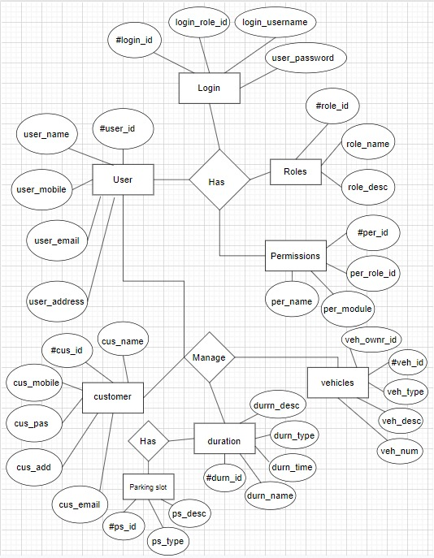

**DFD diagram:**

**ZERO LEVEL:**

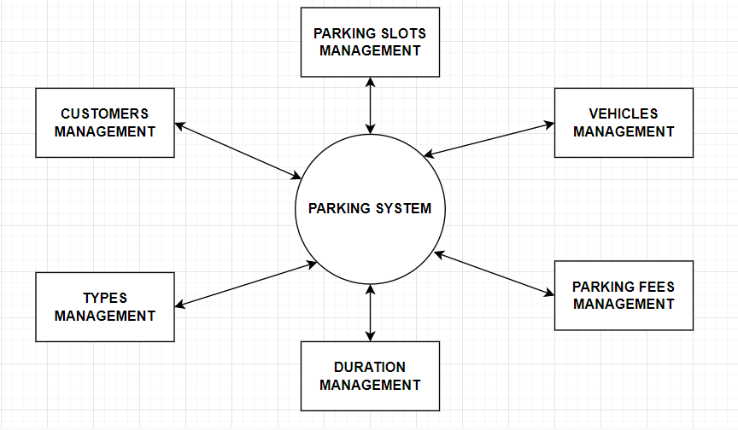

**FIRST LEVEL:**

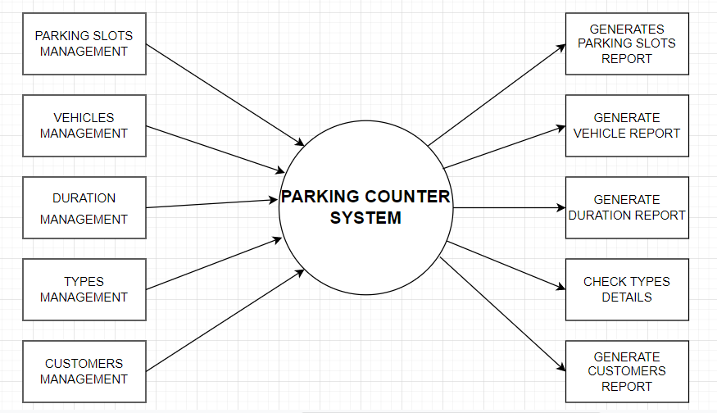

**SECOND LEVEL:**

